Device-based Models with TensorFlow Lite

Week 1

Overview of a tensorflow is and how it works to bring machine learning models to mobile and embedding system.

Features for a mobile AI platform

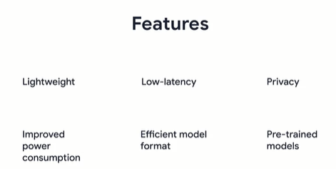

Lightweight 🡪 their goal is to be lightweight working on small low power devices like phones, and they may not be as accurate as those which run on supercomputers in the cloud

Low-latency 🡪 Tensorflow lite is a solution designed to run on devices with low latency without the need for an internet connection.

Privacy 🡪 With this, we could avoid following one regime where it would involve taking a round trip to a model server. Since TFLite uses on device ML to operate, there’s absolutely no need for data to leave the device in sharing your privacy

Improved power consumption 🡪 It can also help improve power consumption as you might already be aware that network connections can tend to be very power hungry.

Efficient model format 🡪 models in TFLite are designed to have a small binary size with just a minor impact on accuracy

Pre-trained models 🡪 when it comes to availability of pre-trained models, TensorFlow Lite has just about everything you need for the most common machine learning tasks, as well as sample examples that you could try out just to see how a model would run on a mobile device. To accomplish some other tasks, TensorFlow lite comes with a utility that helps you convert TensorFlow models from their various formats into a special format that’s consumable by TensorFlow lite.

Tensorflow lite comprises of two main components a converter and an interpreter

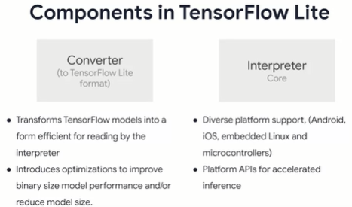

The converter can be used for a tflite model from various model formats and it runs on your model development and training environment. It allows you to optimize your models for optimal performance and even bring down the size of your model

The interpreters, which runs on ur mobile device deals with the inference of these converted models. The interpreters core is responsible for executing these models and client applications using a reduce set of tf’s operators it uses a costum memory allocator, which is less dynamic to ensure minimal load, initialization and execution latency. It also provides support for a wide range devices both in mobile and Iot along with their hardware accelerated APIs

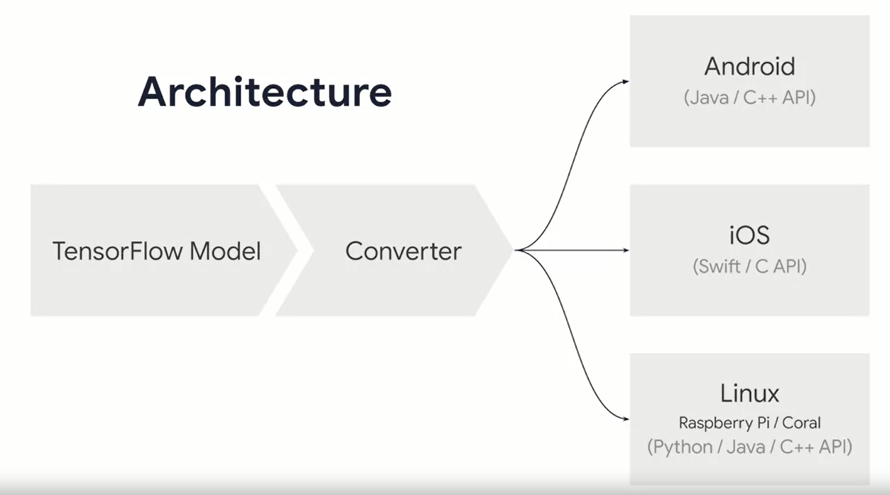

Once you’ve trained model, it has to go through a process of conversion before it can be used on a device first you have to train your model with tensorflow.and typically youll them save it out in a common format. After we have it, we’ll use the tensorflow lite converter tools to flatten the model to prepare it for mobile and embedded device.

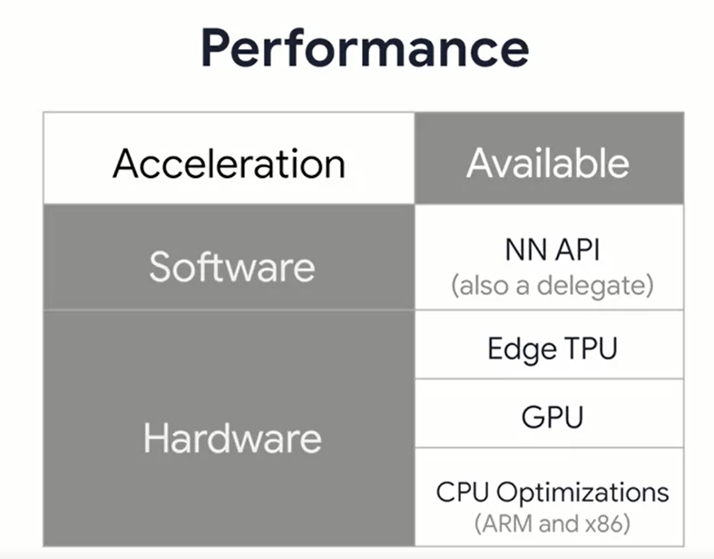

Running inference on computer heavy machine learning models on mobile devices is resource demanding due to a device has limited processing and power. So inference on these devices has to be performed very quickly to avoid overhead an make real-time applications possible for this purpose tflite can employ hardware acceleration libraries or APIs for supported devices.

One way to improve inference on android devices is by leveraging androids neural network api. Secondly inference can be boosted with edge TPUs uses as their solely built for operating on DL models. This is not just limited to serving models, but also to training them they’re also known to be high performing and have a low power footprint while being pretty small in size.

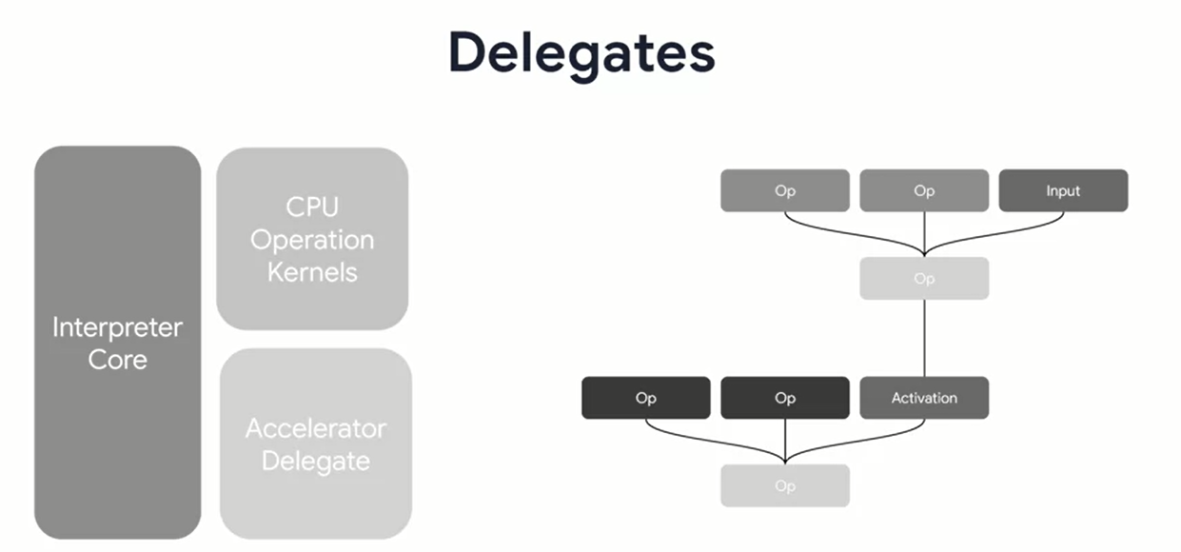

Another form of acceleration which comes in tensorflow lite is a tfl delegate which is a way to pas your graph execution to Hardware that’s specialized to run inference. For this, tfl provides go to support for an experimental GPU delegate that can be used to accelerate models on devices that have an available GPU.

Optimization techniques

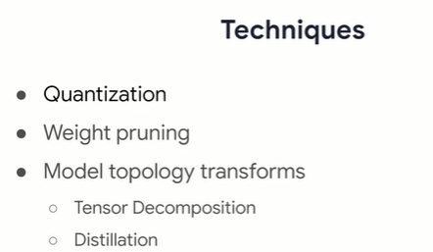

Opt is necessary because of the generally limited resources on mobile and embedded devices. There are several methods that one can use to achieve these types of optimizations and these includes quantization, which reduces the precision of the numbers in the weights and biases of the model. There’s also weight pruning which reduces to overall number of parameters and model topology transform whose goal is to convert the overall mode topology to get a more efficient model to begin with.

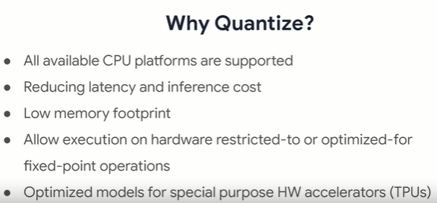

We’ll mostly focus on quantization because that can give you the biggest and the easiest immediate gains. Quantization optimizer your model with reduced precision representations of weights and optionally activation for both storage and computation. The benefit listed above.

Workflow:

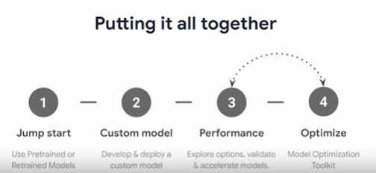

So our workflow with tensorflow light is pretty straightforward. We can start with an existing model and convert it for TF lite r you may even have a model that’s already optimized will look at some of them over the next few weeks. You can take your costum models and TF lite too, converting them and optimizing them for mobile performance.

The process to get tfl model

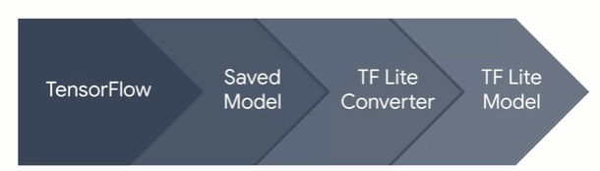

What is tfl converter

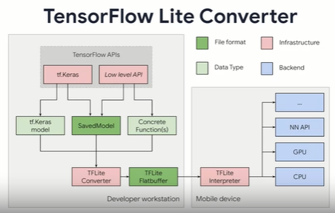

When we create a model with TF using the Keras APIs, we’ll save it out as a keras model, a saved model or a set of concreate in memory functions. The converter takes these and converts to the .TFlite formats which is a flat buffer that can then be used on the mobile device along with optional back ends like the nn APIs or GPUs.

To do the conversion we can use this:

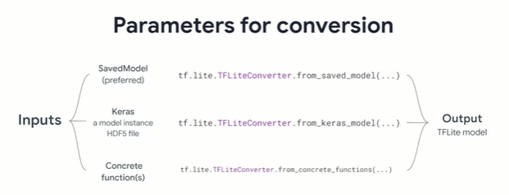

The preferred standard methodology for saving models in tensorflow 2.0 is the SavedModel format

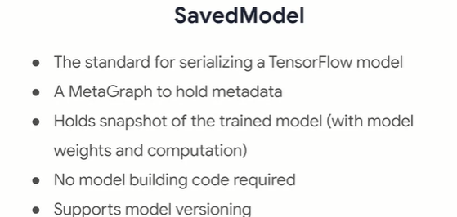

It’s been designed to be a universal language neutral recoverable wat of serializing a TF model. It makes it easier for higher level systms to produce, transform, and consume TF models using a single abstraction. With SavedModel, you can forget the code that was originally used for building the model rendering models to be share and deployed easily with TensorFlow lite, TensorFlow.js, TensorFlow Serving, and TensorFlow Hub. A mMetagraph will be created when a SavedModel is exported. This MetaGaph is essentially a data flow graph comprising of any variable associated with the model, any additional assets such as list of labels or classes that may be required along with signatures for prediction.

Inspecting with SavedModel’s CLI

To understand the inference and the signature of a SavedModel, we can call the SavedModel CLI script and get details about it with coede like this

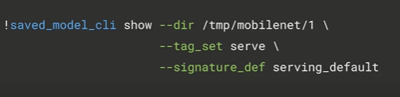

We’ll see the result like this

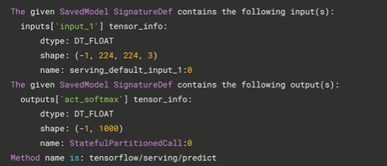

To export a savedmodel that was built with keras or if its one of the built in ones, we can call

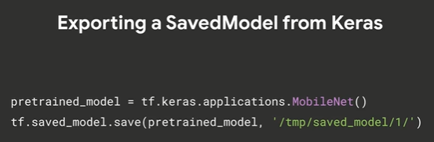

This will bundle all the weights as well as the model architecture. You can notice there’s a safe path convention being followed which is used by TF serving wehre the last path components, in this case, the number one is a version number for you model. It allows tools like TensorFlow Serving to pick the latest version by default seve, therby indicating its freshness.

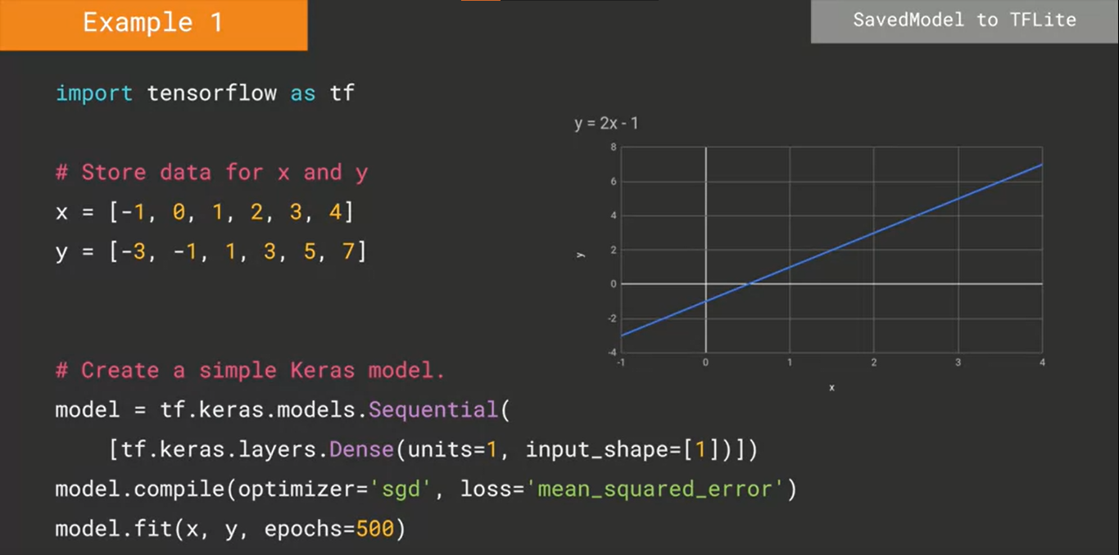

One you have the model we can follow this three steps:

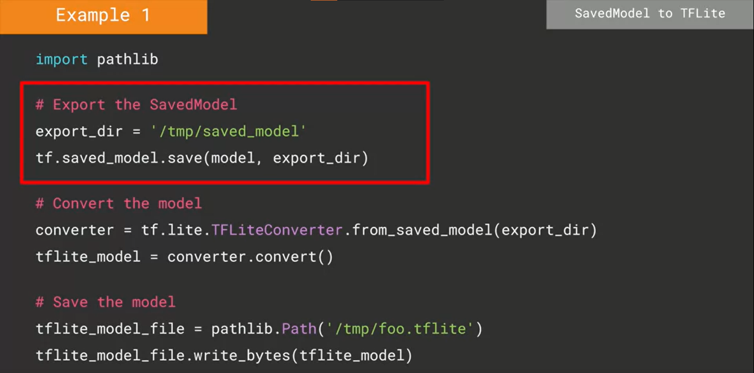

Example Pre Trained model

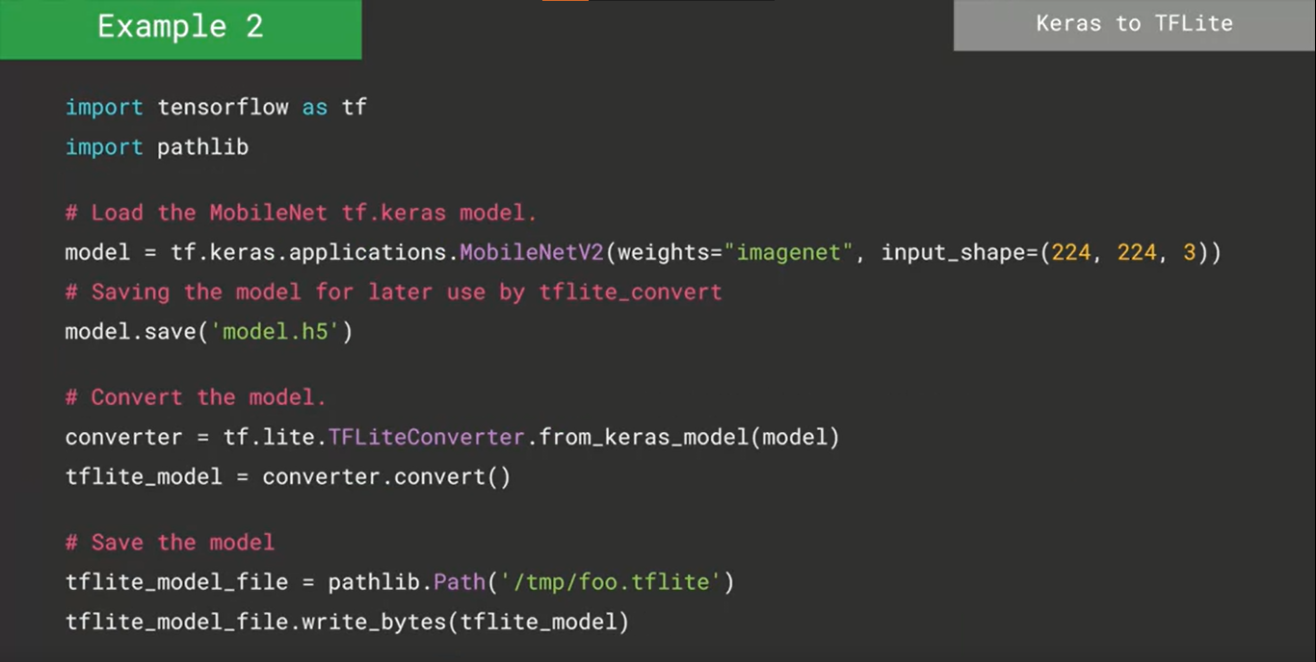

In cmd

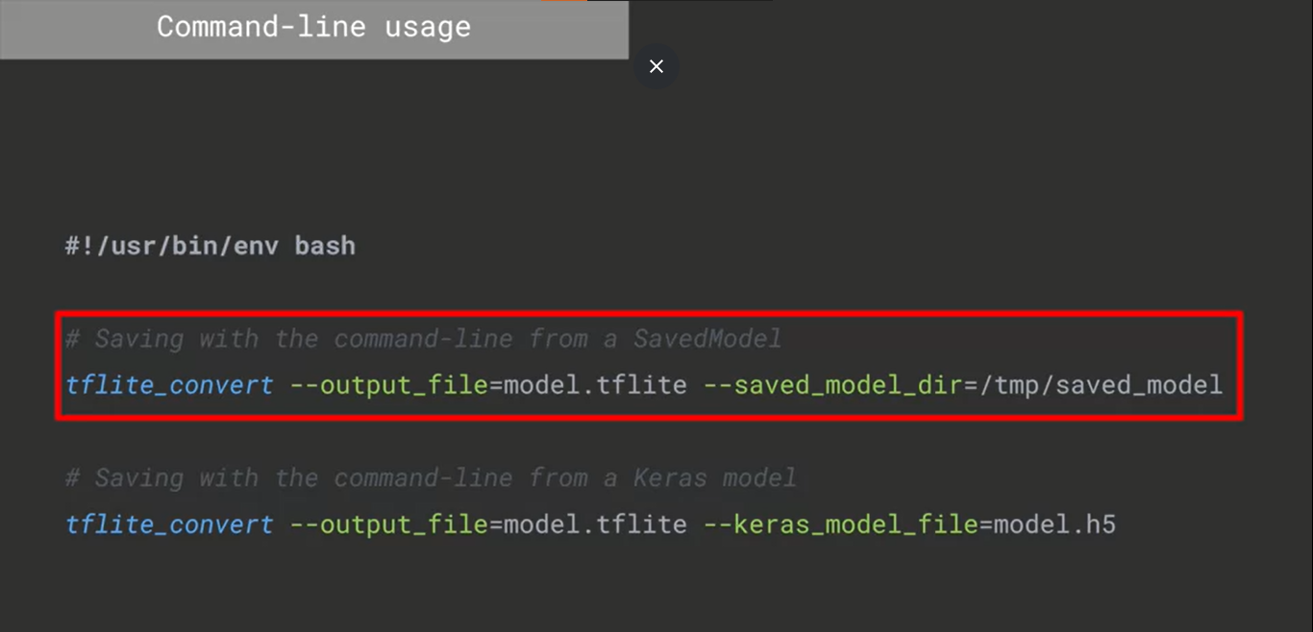

Quantization

One method to achieve this is post training quantization

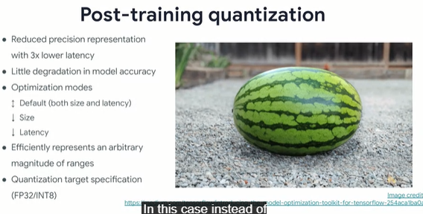

Instrad of quantizing a model during training and effectively changing your training code, you instrrad quantize as part of the process of converting the model to theTFl format. It converts all the floats in the weighs of the model into ints. We’ll get much better latency which through experiment has been found to be up to aout 3x less with a relatively minor degradation in model accuracy.

Code where we override the default behavior of the converter to optimize primarily for size, we could also specify if we want to opti for latency for improved performance or just leve it to default where the converter will try to figure out the best balance between size and latency

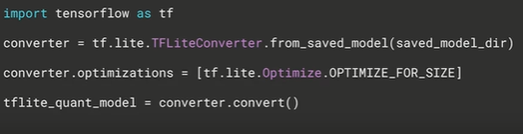

Post training integer quantization

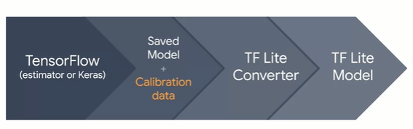

Model up to four times smaller. Ex:

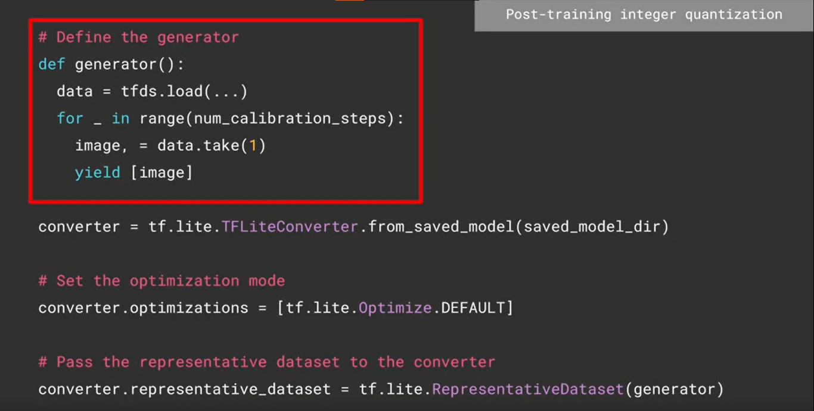

representative data set is used for evaluating optimizations by recording dynamic ranges. This is done by running multiple inferences on a floating point TensorFlow Lite model using the user provided representative data set as an input. We can then use the values log from inferences to determine the scaling parameters needed to execute all tensors of the model in integer arithmetic.

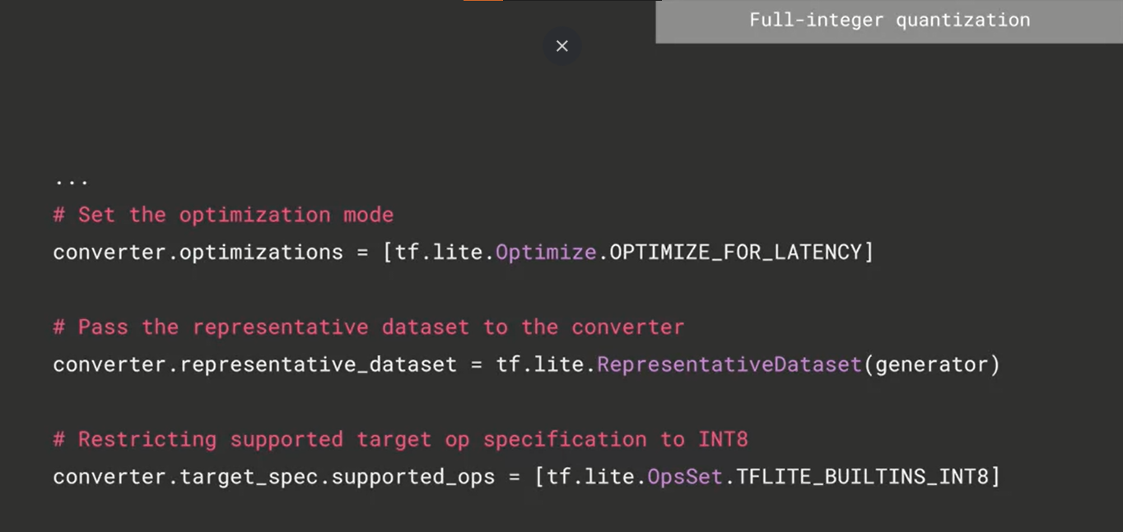

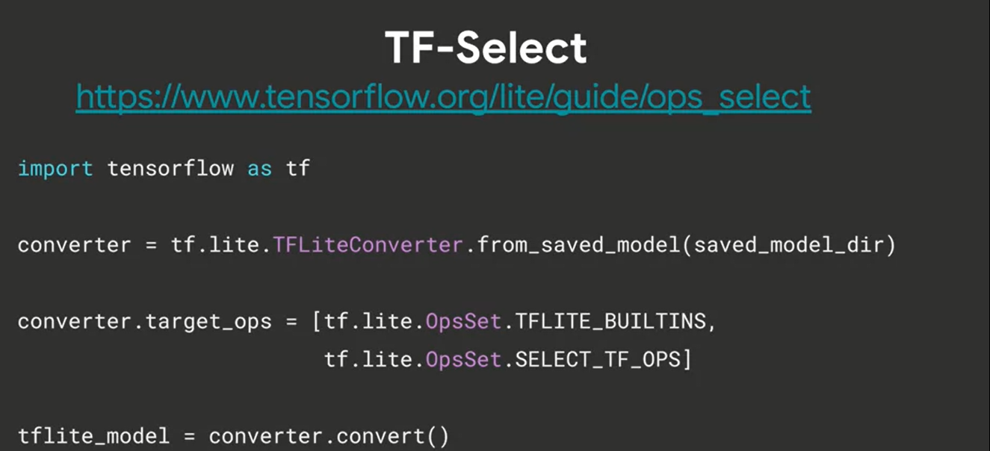

Path of optimizing models

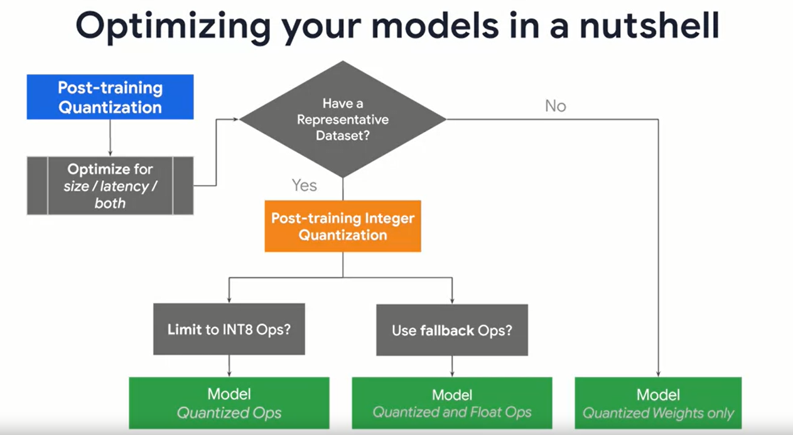

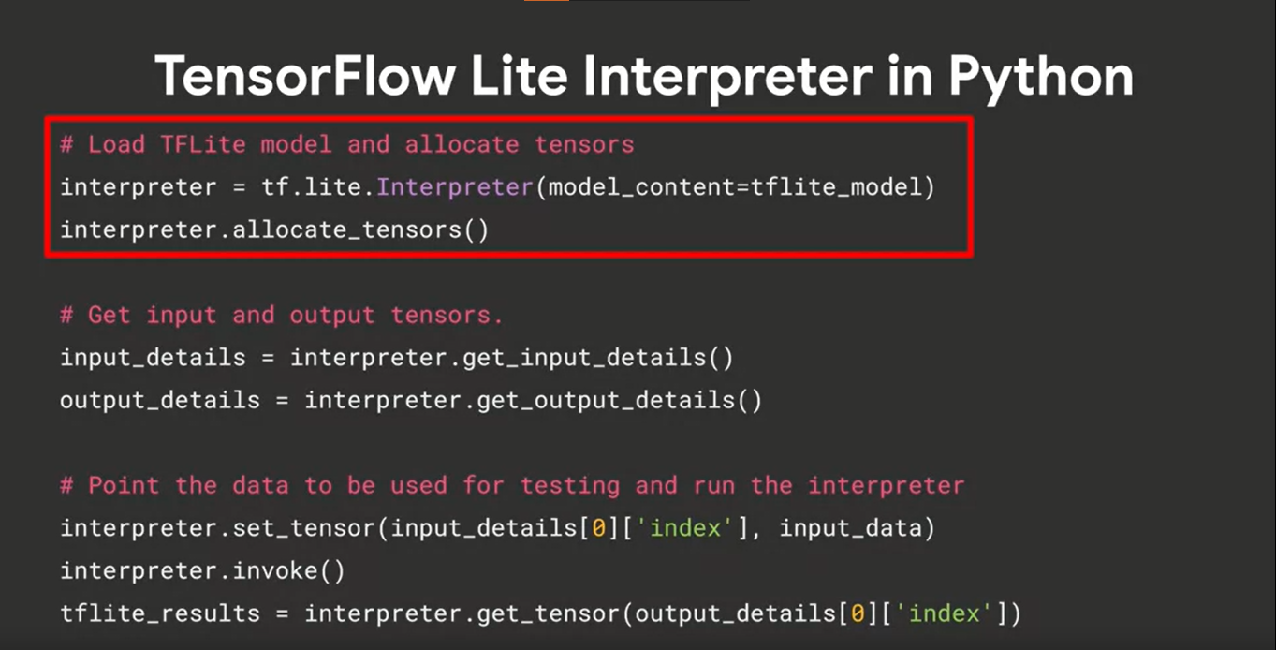

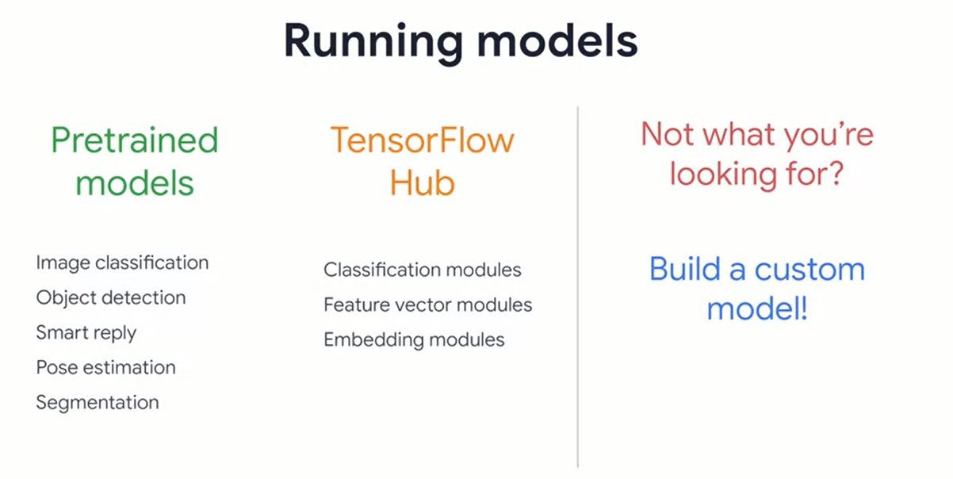

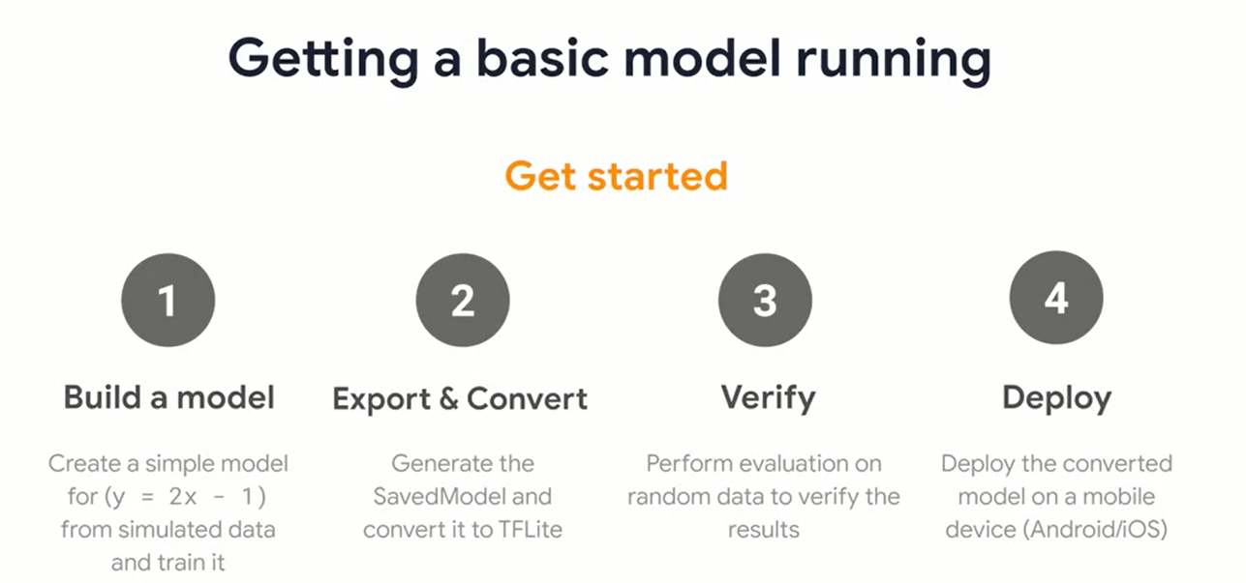

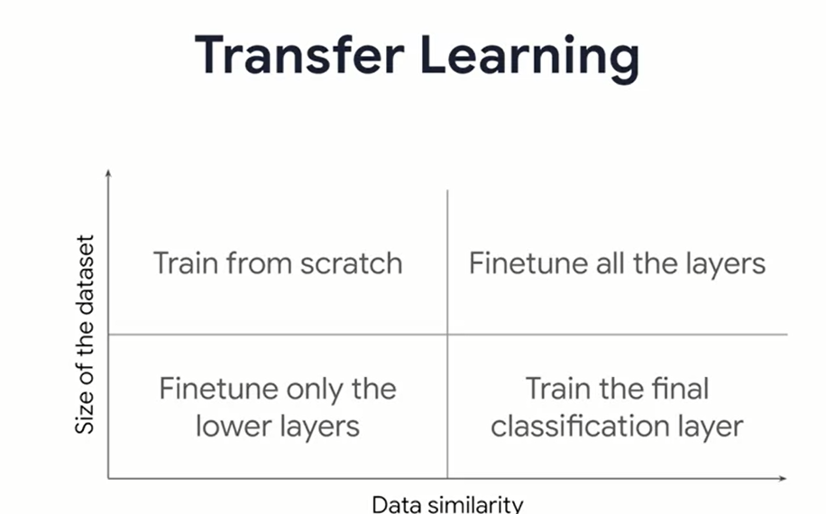

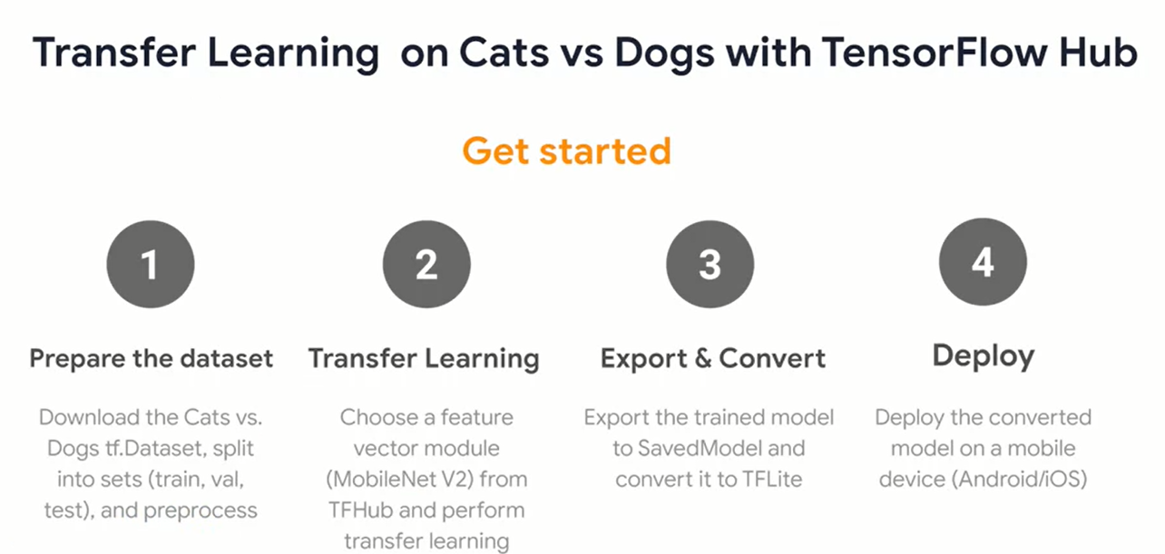

Week2

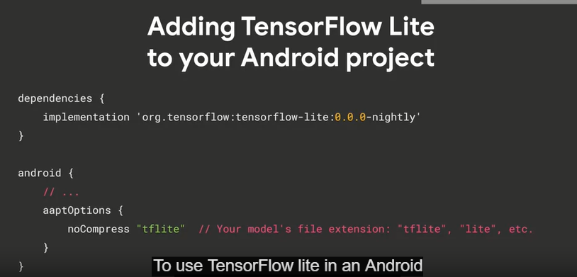

App looks like in android:

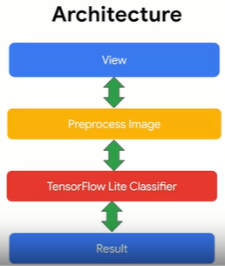

Architecturally you’ll follow the process of getting an image from a vies, preprocessing it, and then feeding it to the tf lite interpreter to classify it. This will produce results that we can render out to the user.

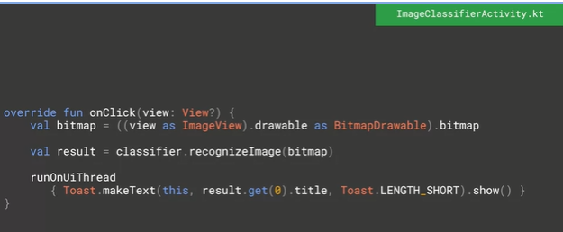

These 3 lines of code execute whenever the user taps or click on the view.

R2 🡪 is that the current view is found, and its image is extracted as a bitmap, and then loaded into the bitmap variable

R3 🡪 then passed to the classifier module, wwhich is kotlin code, that wraps the interpreter object, and a result is returned

R5 🡪 the title of the result is then passed to a toast to be rendered

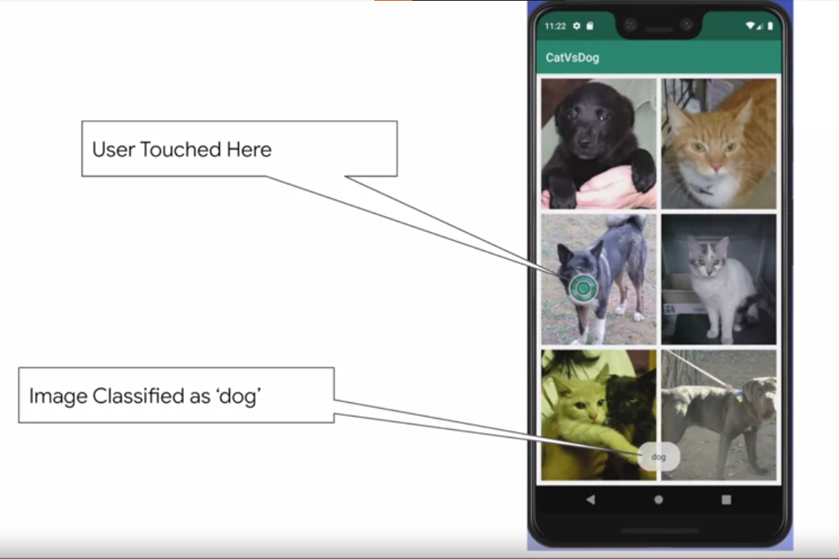

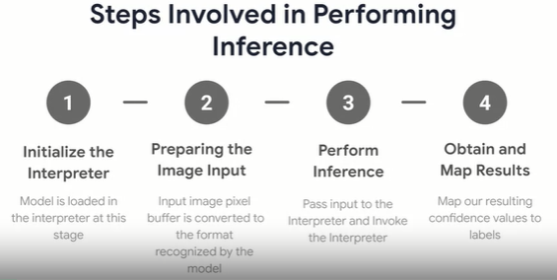

1 initializing the interpreter

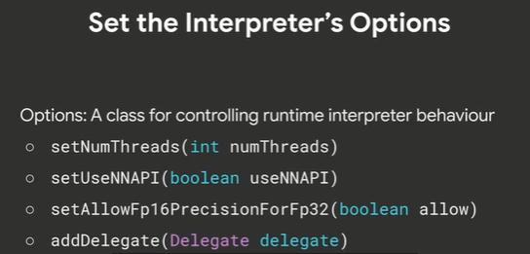

Example of using those option:

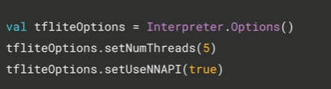

Loading the model and labels:

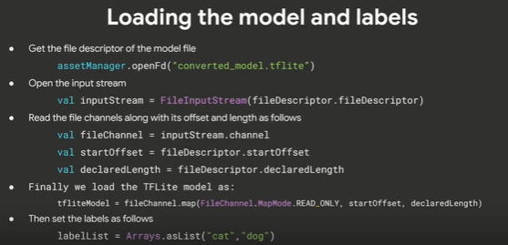

Once we have the model, its then simple to instantiate the interpreter:

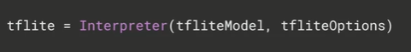

2 Next step is to prepare the images for inputs

Because the expect the input image is set to some point (ex: 24x24,etc) we need to

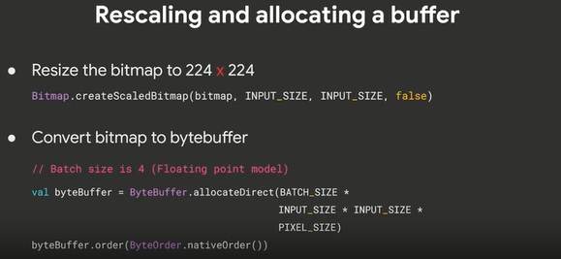

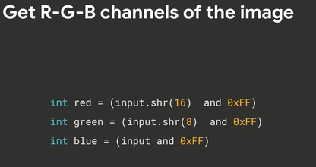

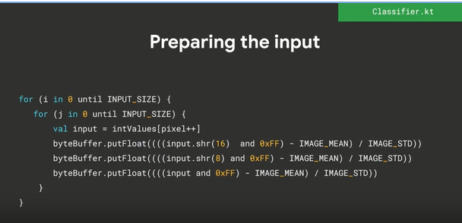

3 run the inference by calling the interpreter

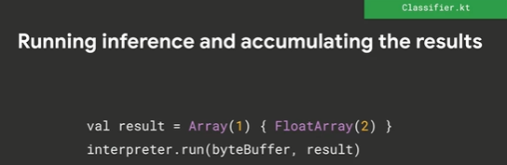

4 read out the results

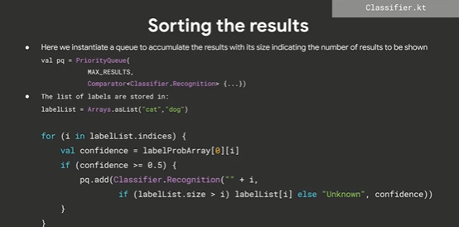

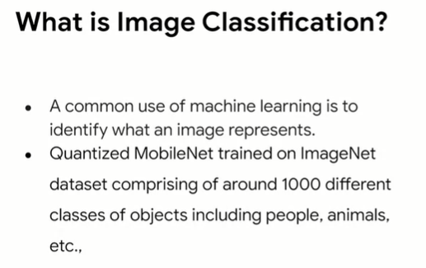

Image classification is a common use pattern for ML and computer vision where a live feed is sliced into frame by frame images and these are pre-processed and passed to a model for inference in the case. As previously we will go through 4 steps:

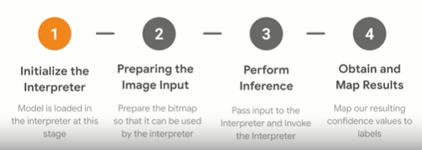

1

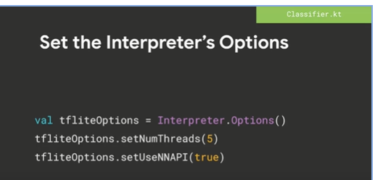

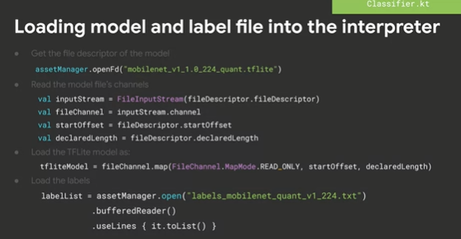

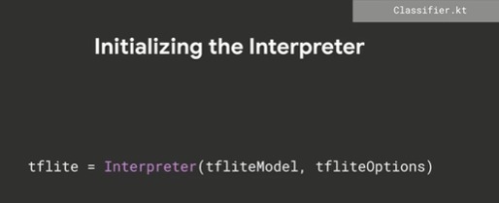

2

We’ll get this directly from camera

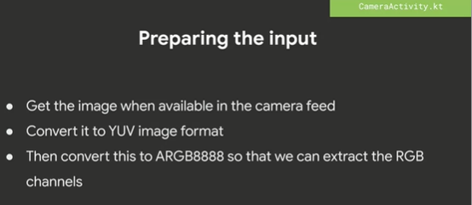

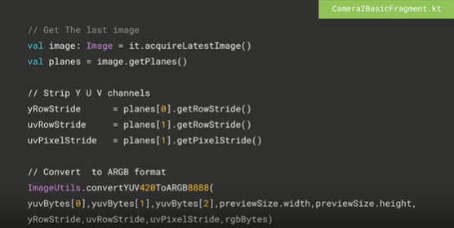

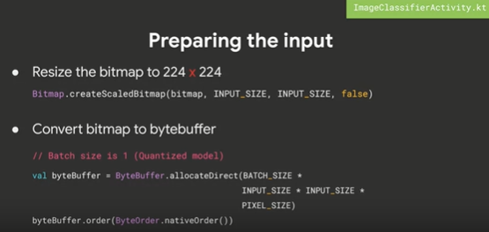

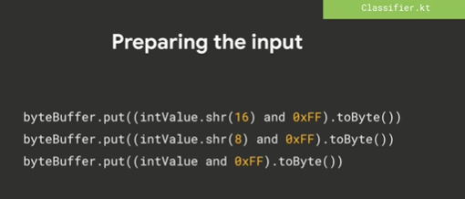

3

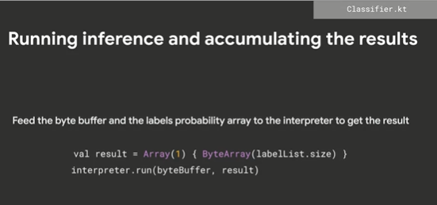

4

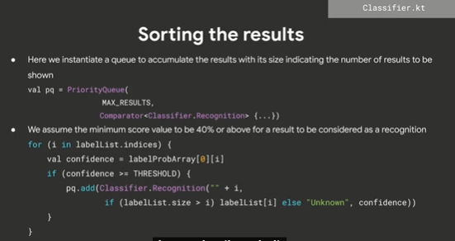

Object Detection

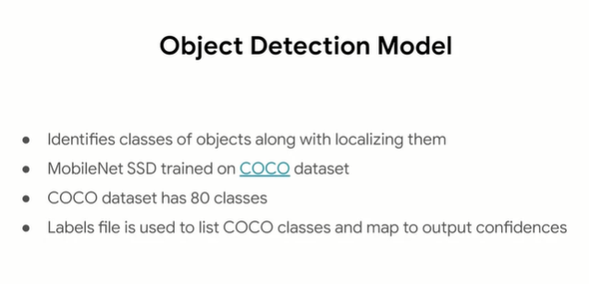

Back again with 4 steps:

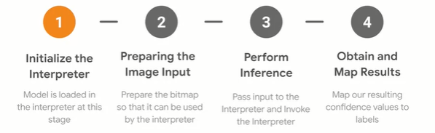

1

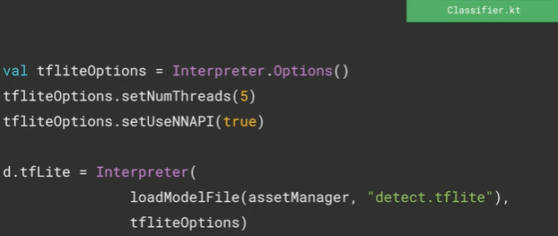

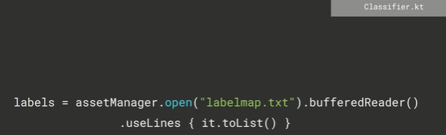

2

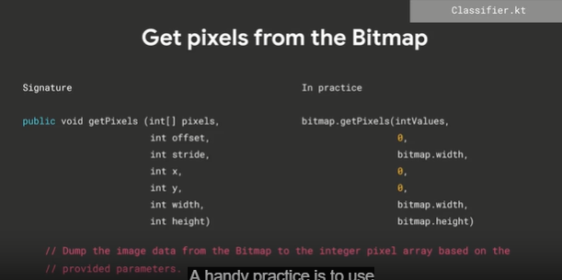

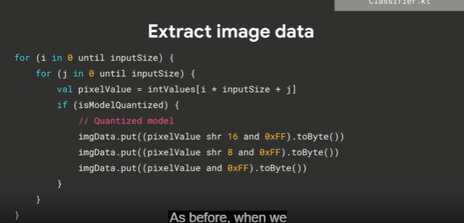

3

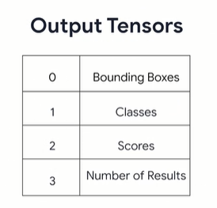

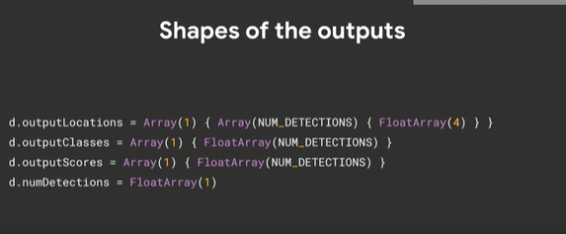

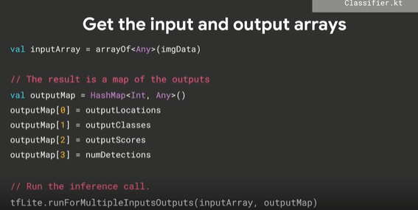

4

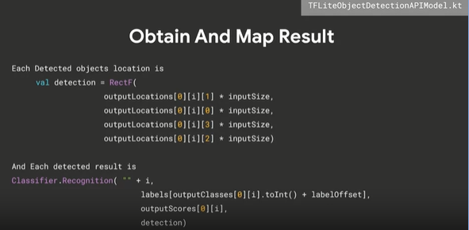

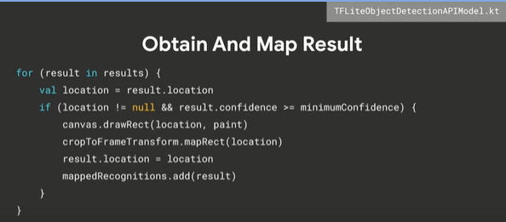

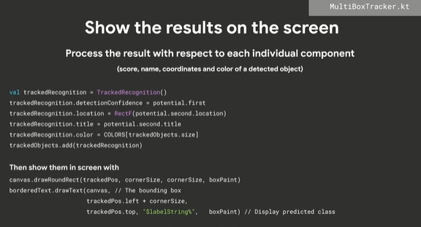

Week 3

This week I’ll do exactly the same thing as last week, but in IOS (need mac device and developer account)

Swift 🡪 mobile dev in IOS

In order to use tflite in swift, there’s a TF Lite Swift Pod

TFlite can be integrated with ur IOS apps written in swift, using the TFLite Swift Library.

TO add TFLite to your IOS Project you use pod file, the tech called cocoapods

Install it using:

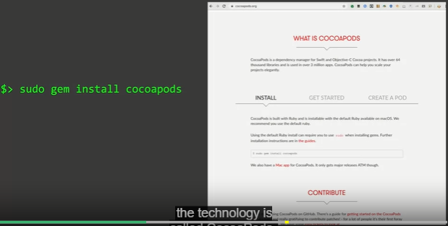\

Then in our projext directory you put a file called pod with no extension, then you add the text pod TensorflowLiteSwift, and do the install command:

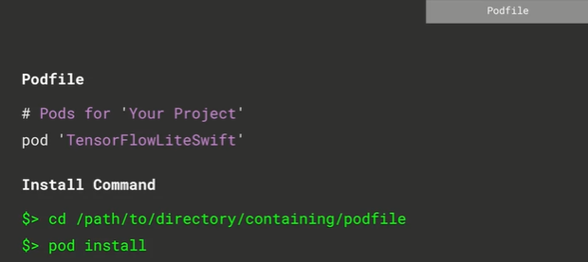

This will add the dependencies and create a new.xcworkspace folder and you’ll work with that going forward

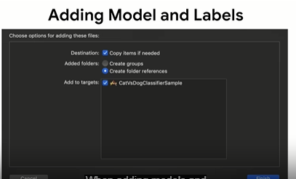

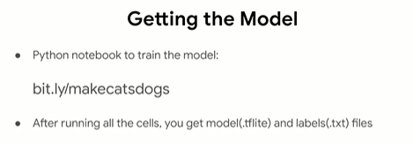

To add model and label we can just drag them to your project folder in Xcode, one thing to note, however, is that you’ll need to check the copy items if needed, checkbox and Xcode. This ensures that the model and labels file are deployed to the device or emulator when you run.

Flow and High level structure for cats vs dogs app:

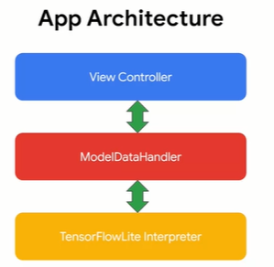

A simple app like this has a single view controller that is responsible for displaying the images and the results. You will also note that there’s a ModelDataHandler.swift file, and this hosts the model data handler class that is responsible for performing the core functionality related to setting up the TF Lite model, preproc the input into the format required by the model and performing the inference by making calls to the TFLite library. The model data handler is written so as to modularize the code and move all of the model-related manipulation into one class for the sake of clarity in this example. The ViewController hands over the pixel buffer of the image on which inference will be performed to the model data handle. The model data handler performs the inference by initializing the necessary objects from the TF Lite library and hands back the results to the viewcontroller which in turn then display them on the screen.

So lets see from the bottom, the tensorflow Lite Inference:

Inference is performed by the class named interpreter, in the TF lite libray

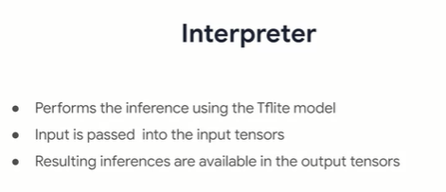

So going back with the 4 process like android

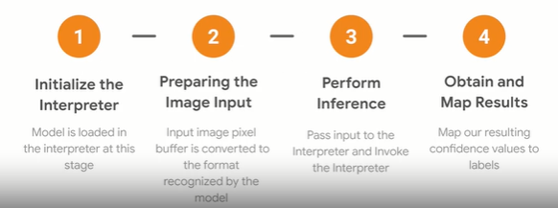

1

Initialize the interoreter

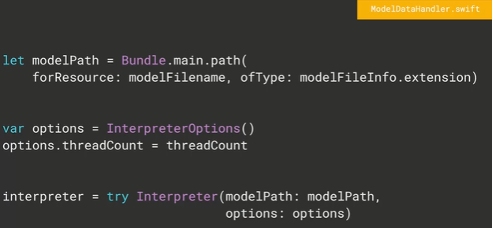

IOS doesn’t support the android nn api so that thing is not available here

And then allocate the input tensors to rreserve memory for them

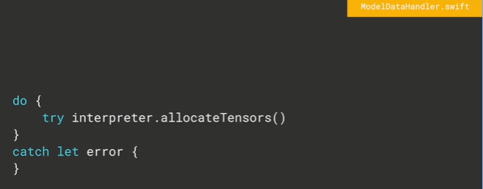

2

Step:

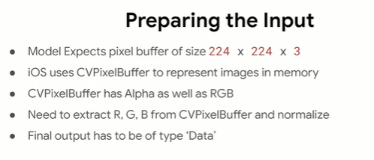

First step:

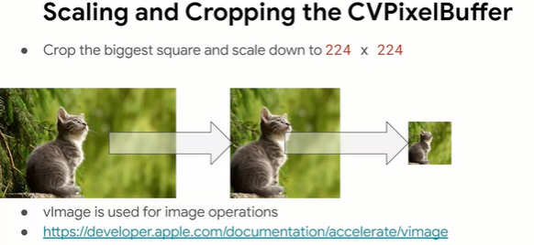

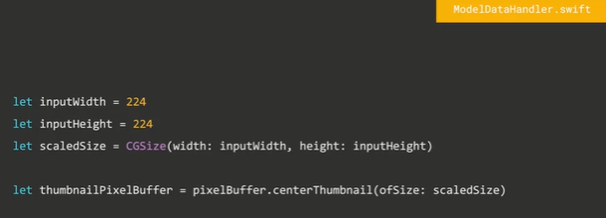

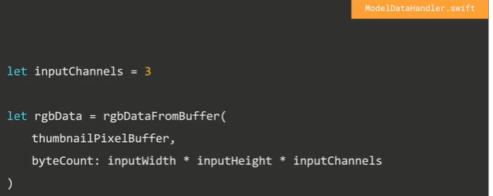

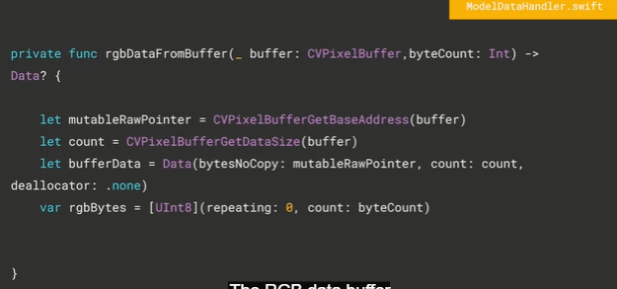

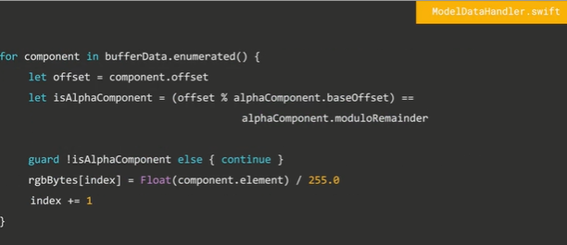

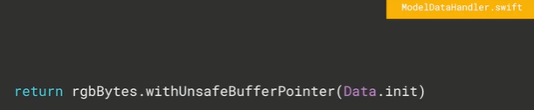

3

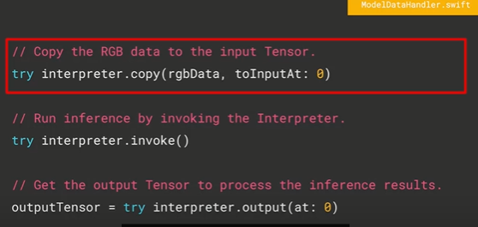

4

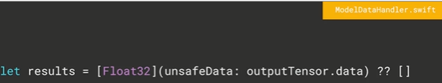

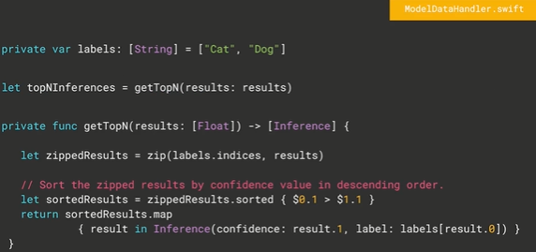

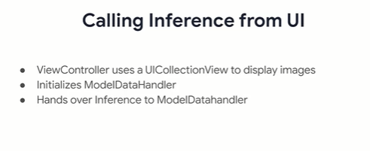

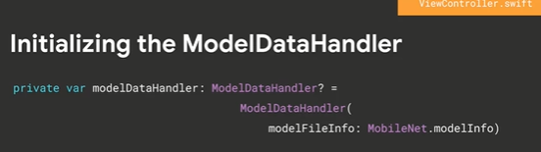

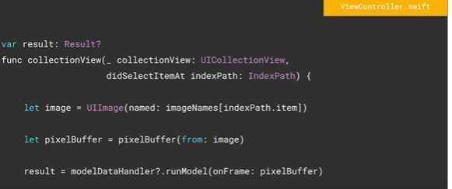

App arch for 2nd app

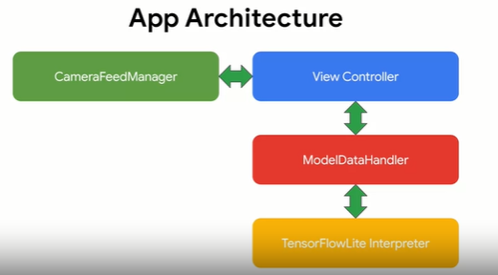

Similar wo the cats vs dogs one. But with the exception of using live feed from the camera with a Camera Feed Manager class, the view controller delegates camera handling to the camera Feed Manager. It’s in turn hands over the camera input frame-by-frame to the view controller. The view controller then hands over these frames to the model data handler for inference.

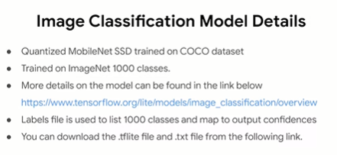

Same 4 steps.

1

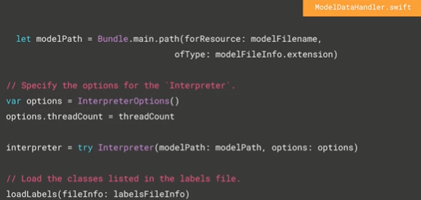

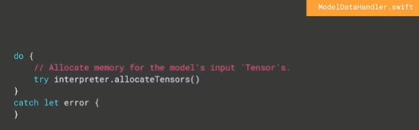

2

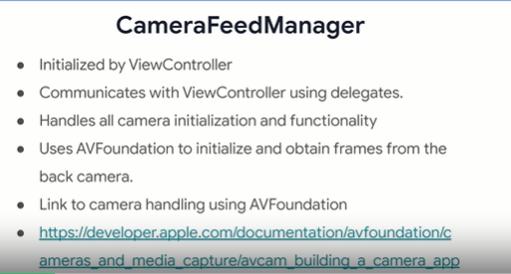

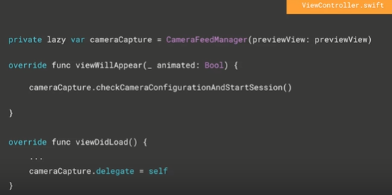

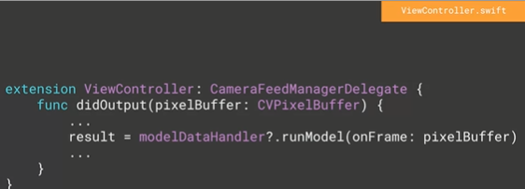

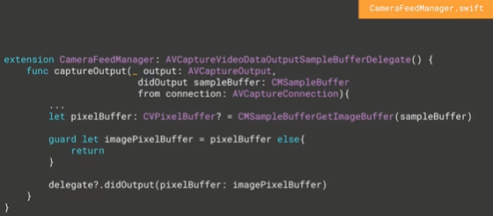

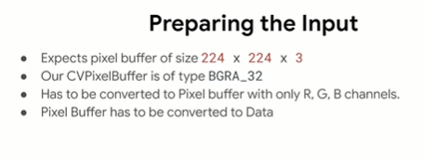

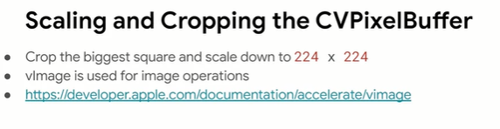

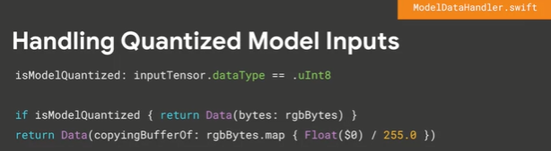

3

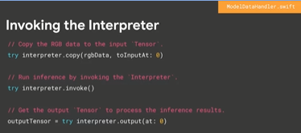

4

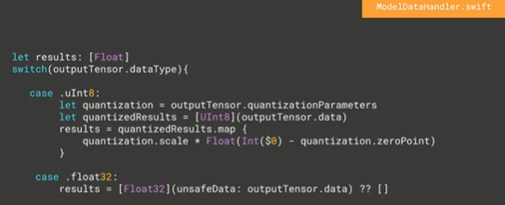

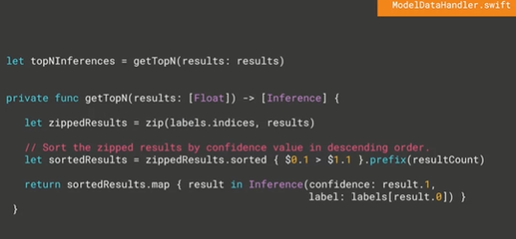

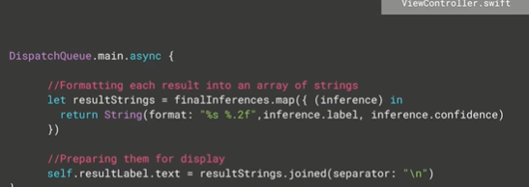

Object detection app

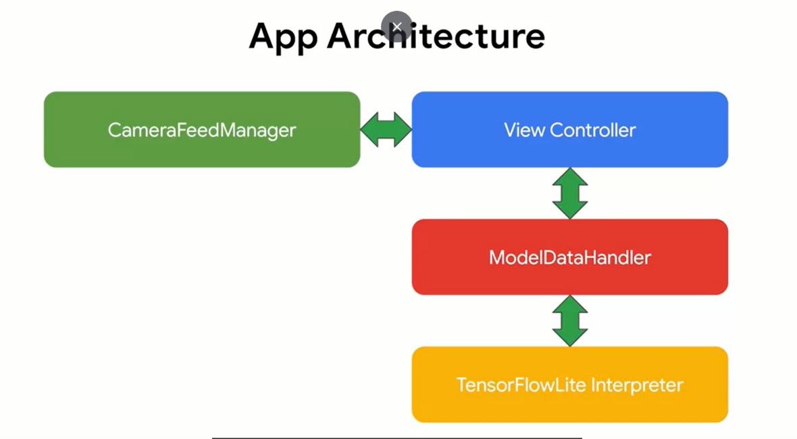

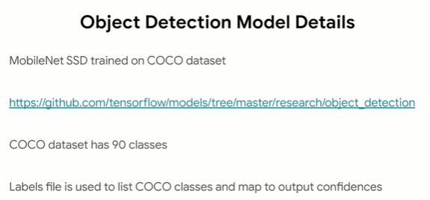

Same 4 steps:

1

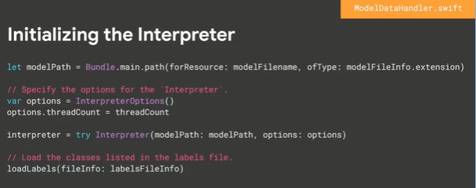

2

Same from before

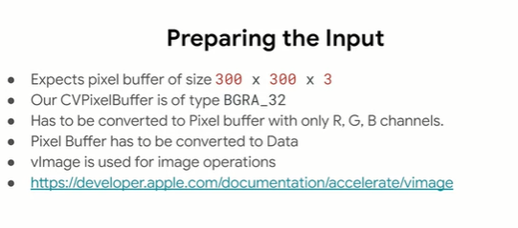

3

Similar as before

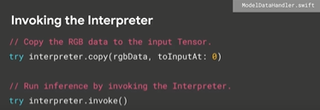

4

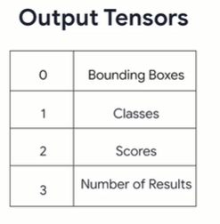

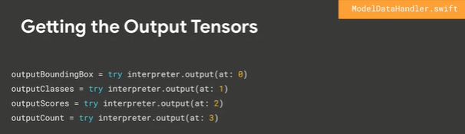

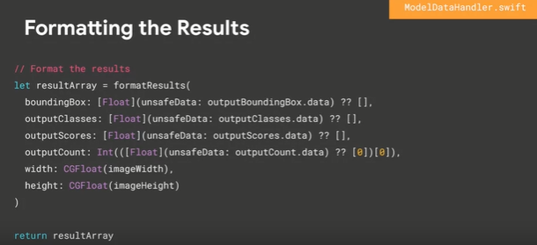

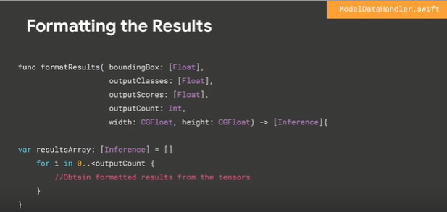

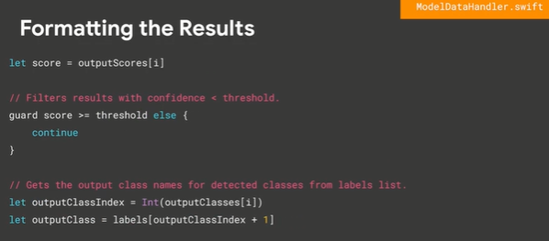

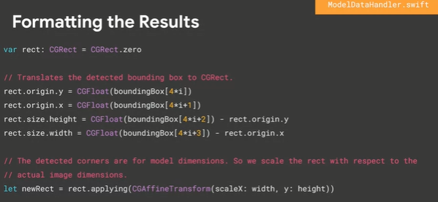

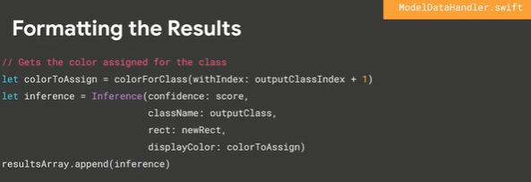

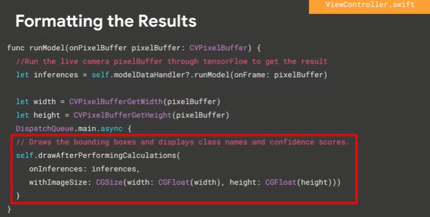

Week 4

This we’ll see the ability to run models on micro-systems with raspberry pi or even micro controllers. Growth Trend of using this device is expected more than phone or laptop. The Factor:

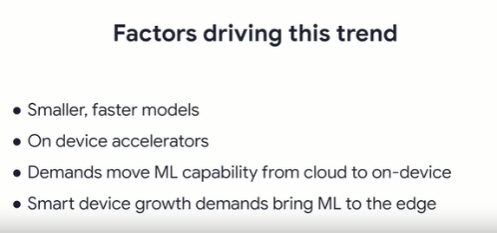

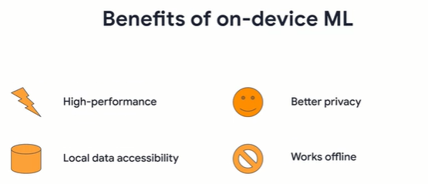

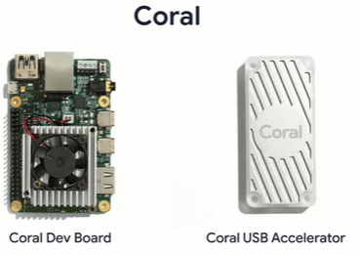

How you can go about performing development with these :

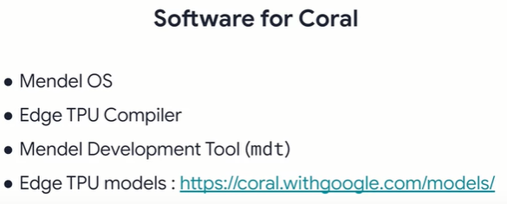

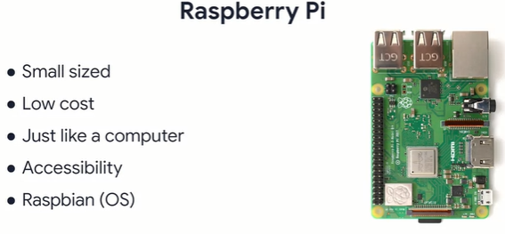

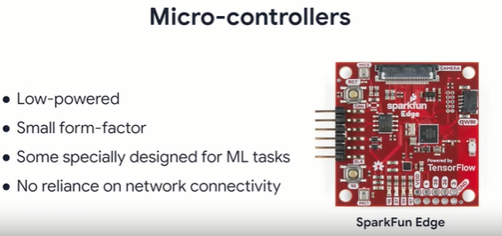’

Starting to woek on raspberry pi, starting with 3 options:

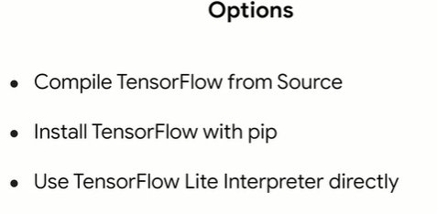

Build from source: (need a docker)

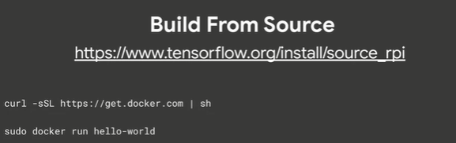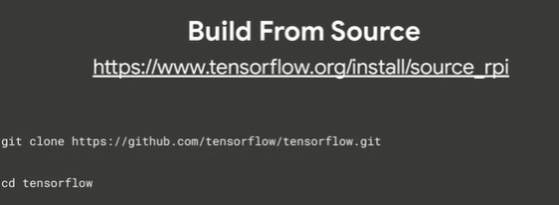

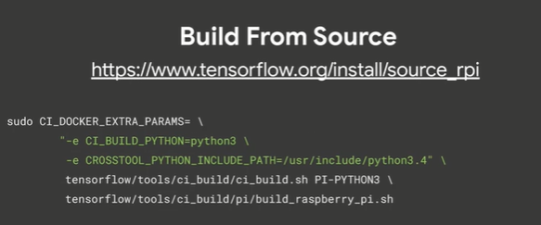

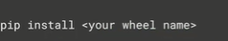

If we want to pre built packages

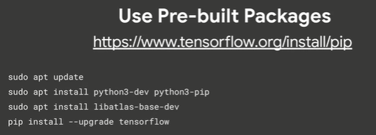

Use interpreter only

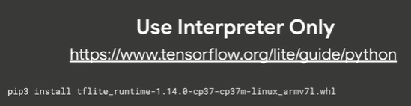

Source:

Opt 1 = <https://github.com/tensorflow/build/tree/master/raspberry_pi_builds>

Opt 2 = <https://www.tensorflow.org/install/pip>

Opt 3 = <https://www.tensorflow.org/lite/guide/python>

Image classification on pie with pre quantize model ( <https://www.tensorflow.org/lite/examples/image_classification/overview> );

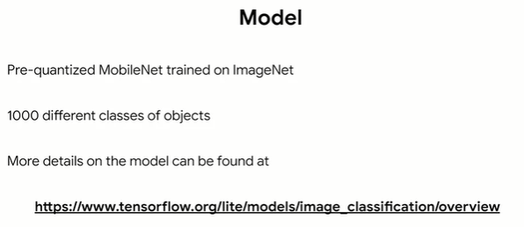

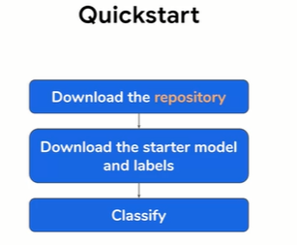

And then start the same 4 process

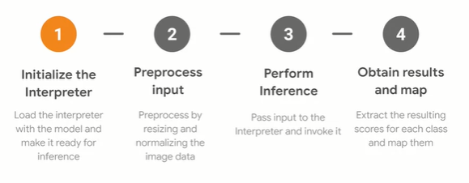

1

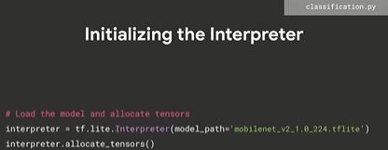

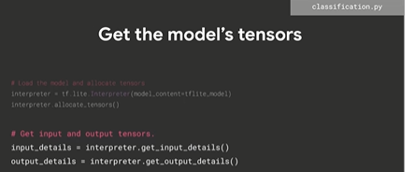

2

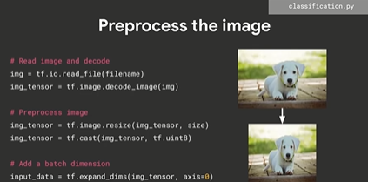

3

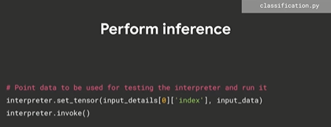

4

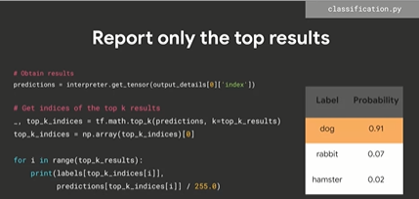

Object detection

Model: <http://storage.googleapis.com/download.tensorflow.org/models/tflite/coco_ssd_mobilenet_v1_1.0_quant_2018_06_29.zip>

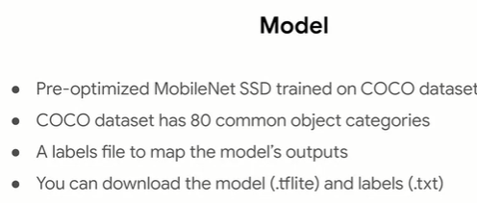

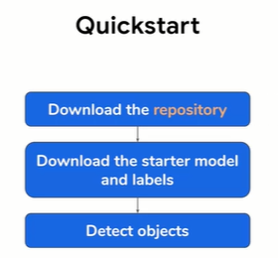

4 step process again;

1

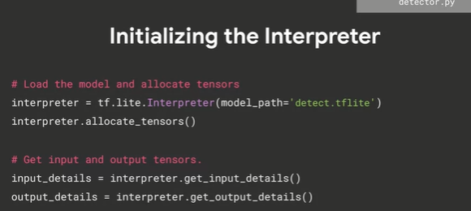

2

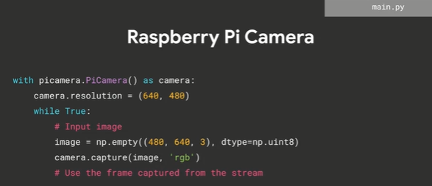

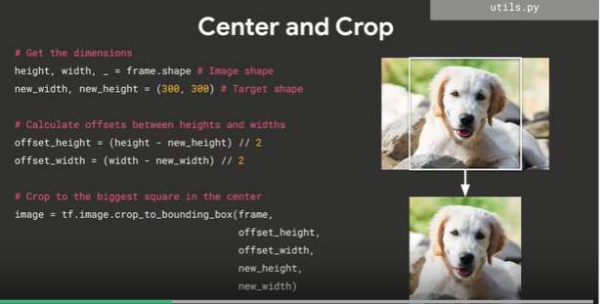

3

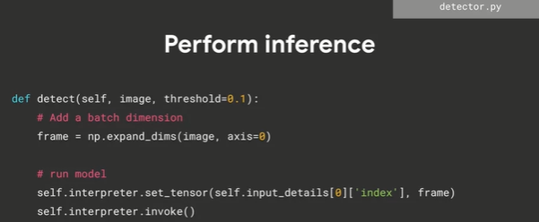

4

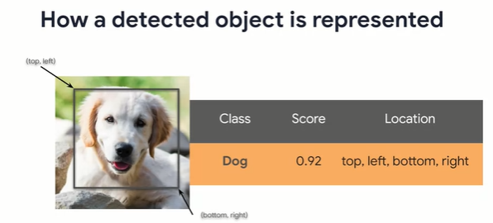

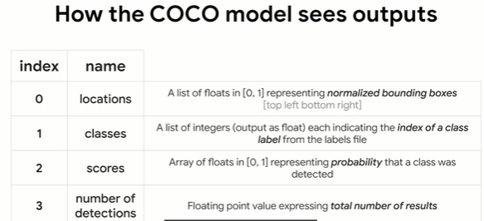

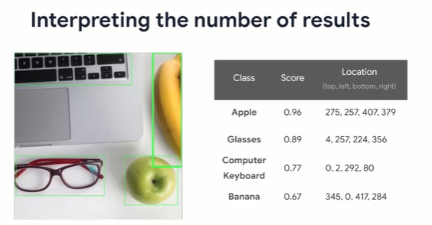

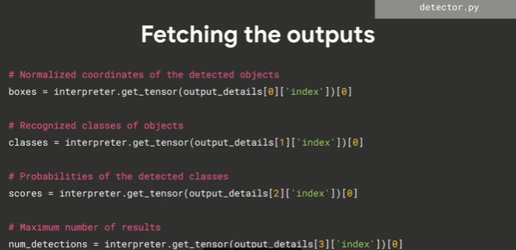

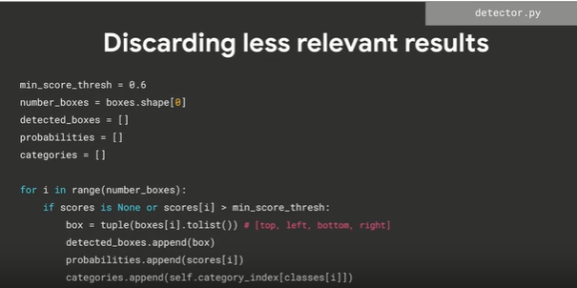

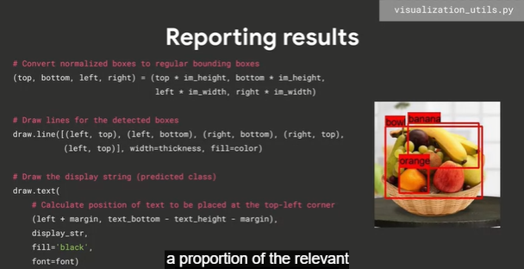

Microcontrollers

Sparkfunedge? It’s a microcontroller-based platform, a tiny computer on a single circuit boad and has a processor, memory, and IO hardware that allows it to send and receive digital signal to other’s devices. It also has four software controllable LEDs and bold primary colors. It also uses a very little enrgy. Unlike a computer, a microcontroller doesn’t usually run an OS instead the programs you write run directly on the hardware.

Suggested links: <https://www.sparkfun.com/products/15170> ; <https://www.sparkfun.com/products/15096> ; <https://codelabs.developers.google.com/codelabs/sparkfun-tensorflow/> ; <https://www.tensorflow.org/lite/microcontrollers/get_started>